Project – Milestone 1

Patrick Weatherford

Bellevue University – DSC 500 T301 2215-1 Spring 2021

Professor Catherine Williams

Abstract

For this milestone of our project our task was to think of 5 potential theories or questions and use Google Trends or some other search engine data to find trends in searches that could either prove or disprove the theory. This was definitely an eye opener regarding the difficulty of finding a topic that would be able to be researched using keyword search trends over time. In this paper, I’ll be reviewing some of the topics that I had in mind along with some initial findings in Google Trends. After reviewing the different topics however, the one that I think will be both interesting and will have a pretty good amount of data in Google Trends is going to be the topic related to Gun Sales and Firearm Mortality Rates.

**Project – Milestone 1**

Below I researched topics related to Gun Sales and Firearm Mortality, Remote Working and Productivity, Increase in Autism Spectrum Disorder, Increase in Child Computer Coding, and Data Science Popularity Over Time.

# Gun Deaths and Gun Sales

For this research topic, the goal is to find out if there is any correlation between gun sales and gun related deaths. For example, do areas with higher gun sales have higher rate of deaths caused by guns? I’ll be using Google Trends to identify areas where users search for terms that indicate that they may want to buy a gun and then compare that with areas known to have more gun deaths.

**Gun Sales**

To find areas with high gun sales, I looked for searches from the past 5 years where the user searched the terms ‘gun store’, ‘gun ammo’, and ‘buy gun’. My assumption is that these terms indicate that someone is interested in buying a gun or ammo and that if an area has more interested people, that more gun sales are likely to occur. Figure 1 below shows these findings.

**Figure 1**

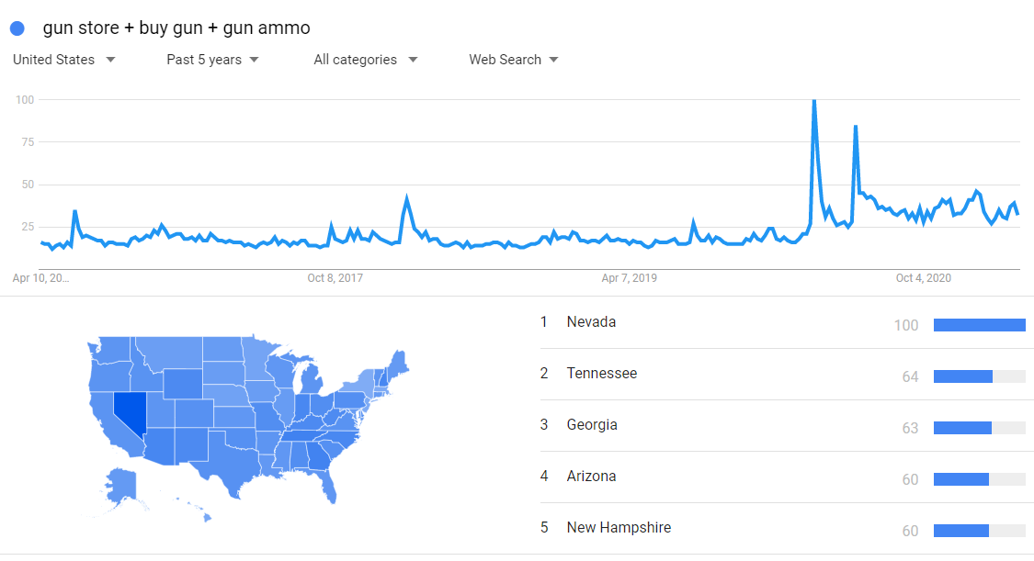*Searches Indicating Interest in Buying Guns or Ammo*

*Note.* Generated using Google Trends.

From Figure 1 Nevada seems to be the state with the highest popularity rate for searches indicating interest in gun sales. In the overall trending line graph, it is interesting to see the number of gun sale searches skyrocket during both the beginning and middle of the COVID-19 pandemic in the year 2020. Since the initial peak, it has stayed higher than it ever has in the past 4 years.

**Gun Crime**

On the CDC website, I was able to locate data related to firearm deaths in the United State. Table 1 below represents data retrieved from 2015 to 2019 which shows the average firearm mortality along with total firearm mortality. The top 10 states with gun searches are highlighted.

**Table 1**

*Firearm Mortality by State (Top 10 Gun Search States Highlighted)*

|  |  |  |
| --- | --- | --- |
| **State** | **Avg Death Rate** | **Total Deaths** |
| AK | 23.32 | 868 |
| MS | 21.62 | 3199 |
| AL | 21.6 | 5268 |
| LA | 21.38 | 4951 |
| MO | 20.14 | 6108 |
| WY | 19.92 | 584 |
| NM | 19.64 | 2076 |
| MT | 19.38 | 1038 |
| AR | 18.64 | 2827 |
| OK | 18.04 | 3555 |
| SC | 18.04 | 4541 |
| TN | 17.54 | 5967 |
| WV | 16.98 | 1601 |
| NV | 16.32 | 2492 |
| KY | 16.14 | 3640 |
| ID | 15.3 | 1318 |
| GA | 15.2 | 8017 |
| AZ | 15.04 | 5481 |
| IN | 14.36 | 4794 |
| CO | 13.94 | 4027 |
| KS | 13.86 | 2006 |
| NC | 13.26 | 6941 |
| UT | 13.14 | 1938 |
| OH | 12.98 | 7643 |
| SD | 12.62 | 535 |
| FL | 12.52 | 13761 |
| ND | 12.36 | 467 |
| TX | 12.22 | 17274 |
| MD | 12.08 | 3621 |
| MI | 12.06 | 6062 |
| PA | 12.02 | 7871 |
| OR | 11.94 | 2612 |
| VA | 11.68 | 5096 |
| DE | 11.26 | 534 |
| IL | 11 | 7002 |
| VT | 10.9 | 367 |

**Table 1 (continued)**

|  |  |  |
| --- | --- | --- |
| WI | 10.5 | 3103 |
| ME | 10.32 | 761 |
| WA | 10.2 | 3904 |
| NH | 10.02 | 710 |
| NE | 9.14 | 888 |
| IA | 8.76 | 1404 |
| MN | 7.82 | 2209 |
| CA | 7.64 | 15448 |
| CT | 5.04 | 925 |
| NJ | 5.02 | 2226 |
| RI | 4.12 | 228 |
| NY | 4.06 | 4146 |
| HI | 3.8 | 281 |
| MA | 3.4 | 1222 |

*Note.* *Stats of the States - Firearm Mortality. (2021).* [*https://www.cdc.gov/nchs/pressroom/sosmap/firearm_mortality/firearm.htm*](https://www.cdc.gov/nchs/pressroom/sosmap/firearm_mortality/firearm.htm)

It seems that a higher interest in buying a gun seems to correlate somewhat with states that have a higher firearm mortality rate. The correlation isn’t as strong as I thought it would be though. There may be other data elements missing that would need to be uncovered to confirm the theory.

**Remote Working Productivity and Happiness**

For this research topic, the goal is to find a correlation between working remote and productivity. During the COVID-19 pandemic a lot of organizations started to utilize remote working, and some have even kept this strategy even after most businesses started allowing employees back in the work area. From my own personal experience working remote, I feel that my productivity and overall happiness have gone up dramatically and want to confirm if this is being seen throughout the workforce. To test this, I’ll be searching for key words which indicate that a person is working remote and then compare that to negative remote working indicators and positive remote working indicators. Figure 2 below shows search trends for ‘Telecommuting’ and ‘working from home’.

**Figure 2**

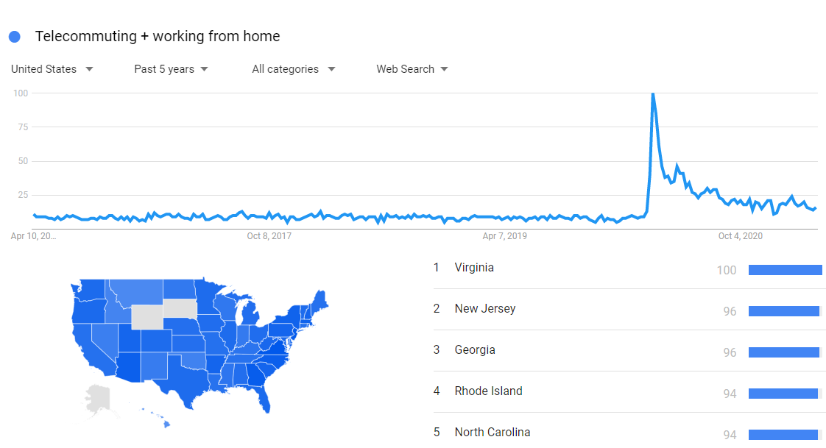*Searches Related to Working from Home*

*Note.* Generated by Google Trends.

After review, this may not be a good topic to research via Google trends due to ambiguity of search topics and lack of supporting data related to working remote. A lot of sites seem to have polls that they’ve generated but even with that, productivity and happiness may be too hard to measure and correlate with working remote.

**More Parents Teaching Kids to Code**

For this topic, my goal is to try and find if there is any sort of increase in coding education for kids. To find this I’ll be looking at popular coding apps for kids and seeing if there is any increase in searches for these apps via Google Trends. Figure 3 below represents my findings.

**Figure 3**

*Searches for Apps That Teach Kids to Code*

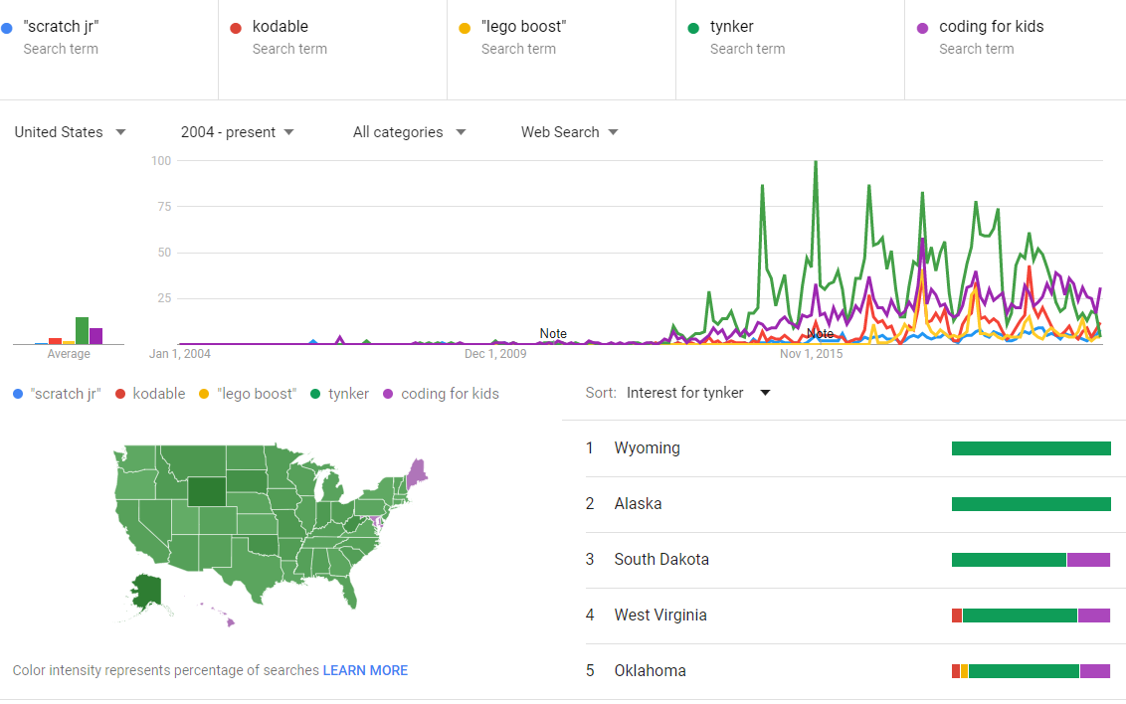*Note.* Generated via Google Trends.

From what the data is showing, it seems there was a spike in searches for apps related to teaching kids to code in the Winter of 2014. More research will need to be done to find indicators for the reason behind this. Also, it is interesting to see that searches increase every Winter and then die down in the Summertime indicating that the popularity is seasonal.

**Autism Spectrum Disorder Rates**

This topic is near-and-dear to my heart. My wife initially rose awareness to me regarding ADS (Autism Spectrum Disorder) which when I first met her, I knew very little about. She is a behavior technician and does 1:1 therapy with children who have ADS. After seeing the struggle that parents and families go through with children who have ADS, I wanted to help and we both got hired to help watch kids with ADS for parents who have no family support and low income. For these parents, the only time that they have is dedicated to watching after their kids and this program is setup to give them a very much needed break occasionally. Back to the project though, I want to do some research to see if there is an increase in ADS rates in children and if so, what types of correlations are there. Figure 4 below shows search popularity trends for keywords indicating that a parent has a child with autism.

**Figure 4**

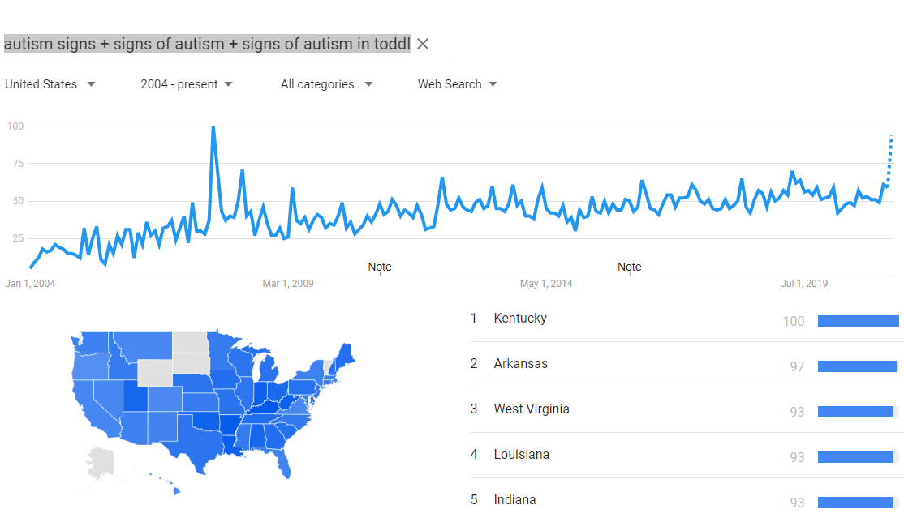*Autism Spectrum Disorder Rates Over Time*

*Note.* Generated by Google Trends.

**Data Science on the Rise**

For this topic, my goal is find out if the field of Data Science is trending or not and find any sort of correlations to these trends that may be a cause for it. Figure 5 below shows keywords searched over time that may indicate Data Science popularity.

**Figure 5**

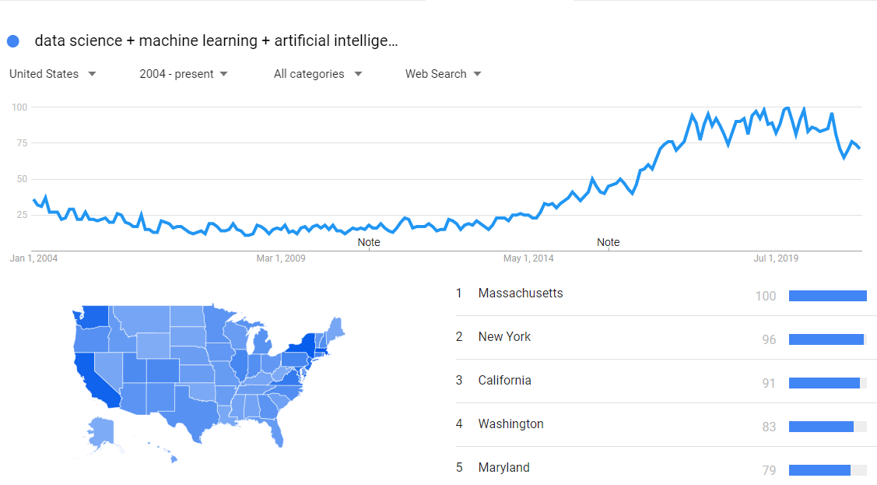*Searches for Data Science Over Time*

*Note.* Generated via Google Trends.

From the looks of it, Data Science popularity had a significant trend upwards since 2014 but has sort of hit a plateau and took a dip down in December of 2020. After reviewing the data though, it seems there is almost always a spike down in popularity for the month of December which I thought was interesting.

References

Stats of the States - Firearm Mortality. (2021). <https://www.cdc.gov/nchs/pressroom/sosmap/firearm_mortality/firearm.htm>